RaspberryPI CES DEMO Board Documentation

Kevin Hague, Seonman Kim
Corporate Technology Group, HARMAN INTERNATIONAL

Revision: 02/15/2016

Table of Contents

PURPOSE: 1
HARDWARE SETUP: 1
Kevin’s PTT (Push to Talk) Switch. 2
CONNECTIVITY: 3
TEST: 3
Developer Setup – coding for this platform 4
Software library installation 6
WAV Player 6
MP3 player 6
Parse Support (only for Alexa client) 6
paho-mqtt-c client library (only for IBM-watson client) 6
WIFI 7
Edit /etc/network/interfaces 7
Key Generation 7
Starting WiFi 7
Auto-start shell script 8
/etc/rc.local 8
== /etc/init.d/start_ibm === 9
Optional Setup 9
BACKUP 9
ADJUSTING MICROPHONE INPUT: 10

PURPOSE:
This document describes the setup, client dev tool and hardware elements require to develop, test and deploy this raspberry pi demo for voice activated systems such as Houndify, Alexa and IBM Watson.

HARDWARE SETUP:

- All descriptions below are for the following configuration:
  - Raspberry Pi2, Model B
  - USB Sound Blaster PLAY! 2 sound input/output
  - Kevin’s PTT switch
- POWER: RaspberryPi is powered by 5vdc through a microUSB connector. Although it can run on some computer USB connections, it is safer to use a 10W power supply.
- Connectivity: All connectivity is provided through a single Ethernet connector. Alternatively WiFi connectivity can be provided through a USB dongle although this is not documented here.

Kevin’s PTT (Push to Talk) Switch.
This will later be wired into the Omni switch.

- This is connected between pin’s 1-11 on the GPIO Header and will raise the GPIO 0 to a level 1 when button is depressed. Resistors keep the input active low to keep false readings minimized.
- CAUTION: Please be a sure to follow the below info in detail. Any mistake could cause a board failure.
- The supplied button and connector is designed to automatically connect to the right leads when the red lead is pushed into pin 1. This is on this inside of the board and closest to the display connector.
- Push connector into the entire header making sure it is seated. It should look like this:
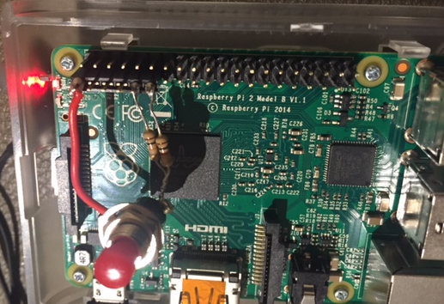

CONNECTIVITY:
- All connectivity is done over TCP/IP and with the SSH protocol.
- The default user/pwd is: root/raspberry
- A Unix/Linux command for SSH is SSH root@192.168.1.3 with the TCP/IP address being assigned by DHCP. If you don’t know what address has been assigned then port scanning or logging into a known DHCP server(local router) is required. Reverse engineer this using the MAC address assigned to the device.

TEST:
- To test, you will need to ensure there is Internet access available, the device IP address has been identified on the network and that SSH is available from the development/users machine.
- Ensure the SoundBlaster is connected to a headphone and is in the top USB port next to the Ethernet jack.
- Connect Ethernet jack to local network. Ensure this network is the same as the PC/Mac used to connect to the device over SSH.
- Power the device with a 2a/10W USB power supply.
- Wait for the raspberryPi to boot. This is typically less than 1 minute.
- Below is an excerpt of the script required for test using the houndify demo:
- ssh root@192.168.1.3
- root@192.168.1.3's password: raspberry
- cd integrationTest/
- ./runAudioClient

Press the red button to ask a question ...

Ask me anything ...

Getting that information for you ...
Received HTTP
Press the red button to ask a question ...
- USE CTRL+C to close the program

Developer Setup – coding for this platform
- SFTP (SSH FTP) is available as a file transfer service. This is the recommended way to move development files between the Raspberry PI File system and developer computer. To Setup use an SFTP client (many available) - I use cyberduck. Setup example here:
  - Create new connection
  - Enter the following info:
  - 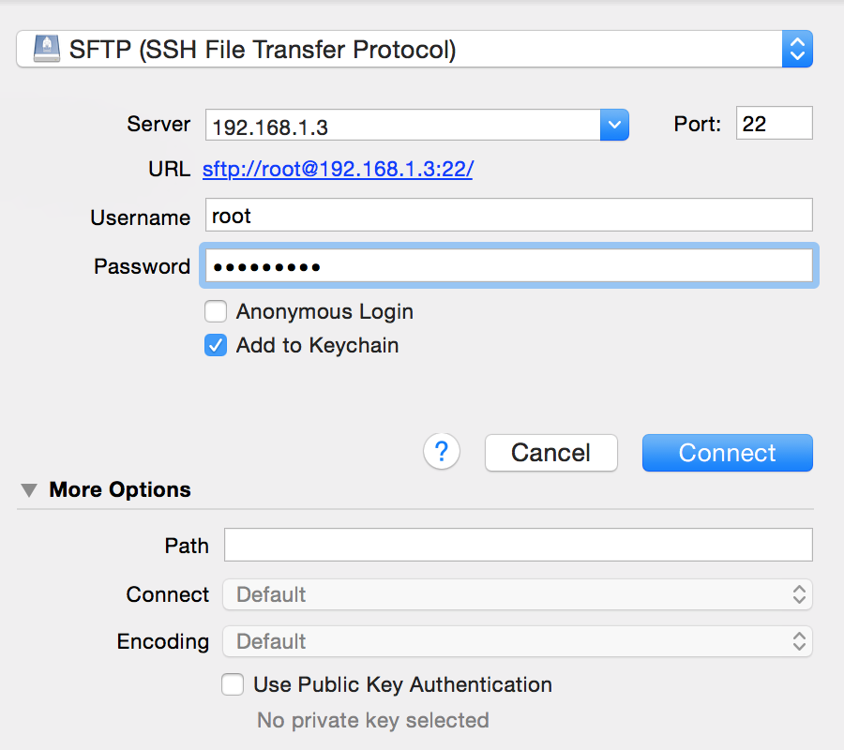
  - Click ok
  - Click Always
  - Click allow:
  - 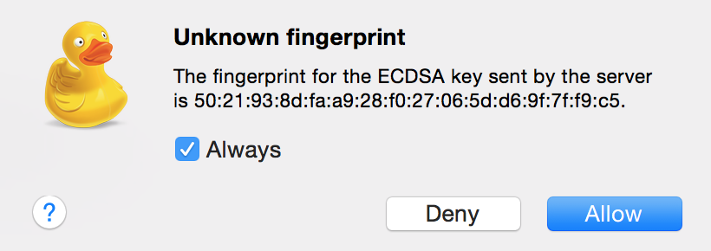
  - Right click, select Synchronize
  - Select a local directory to sync
  - Click ok, this will bring all the root user files down to client computer
- Within the root user folder, two directories exist:
  - integrationTest
    - contains all source and executable files for audio I/O
  - tools [typically not required for testing]
    - wiringPi: A tool to command I/O lines on the raspberry pi
    - Chilkat: SDK Development tools used to support integration Test
- Files:
Main file | audioClient_hcsAzure.cpp
Audio Recording | audio_rec_header.cpp
Audio Playback | audio_record_playback.cpp
Compilation | ./compile_hcsAzure.cmd
Execution | ./runAudioClient

- Coding:
  - Edit the CPP and associated .h files as required.
  - Sync files over SFTP.
  - Compile using the ./compile_alexaAudioClient command
  - Easy!
- USE:
  - Make sure there is an internet connection
  - Use either the supplied splitter with external mic&speaker or a headphone with microphone (like earbuds used to take cellphone calls)
  - Open a ssh terminal window
  - Default ~ directory is /root If unsure use command cd ~
  - Navigate to integrationTest directory cd integrationTest
  - Type ./runAudioClient
  - The screen will display:
root@minibian:~/integrationTest# ./runAudioClient

Press the red button to ask a question …
  - Press the red button for at least ½ second.
  - Screen will now display: “Ask me anything”. Speak into the microphone for up to 5 seconds.
  - Screen will display: Getting that information for you
  - Within a few second audio will play from the speaker/headphones
- SHUTDOWN
  - Type shutdown now

Software library installation

WAV Player
For IBM-Watson client, we need “aplay” for playing wav file. By default, RaspberryPi minibian OS includes aplay. If it is not included, just install it using apt-get

MP3 player
Install mpg321 to play mp3 audio received from Alexa Servier. (IBM watson client does not need mpg321, because it only plays wav.)

$ apt-get -y install mpg321

Parse Support (only for Alexa client)

alexaAudioClient uses Parse Embedded SDK (C/C++) to get refresh token from Harman HKVoiceCloud server, and then receive access token from Alexa server with the refresh token.

Here is how to install parse SDK.
(reference: https://www.parse.com/apps/quickstart#embedded/raspberrypi)

1. Install a few tools on Pi.

sudo apt-get update
sudo apt-get install autoconf automake libtool
sudo apt-get install libcurl4-openssl-dev uuid-dev

2. Download Parse SDK to Pi.

https://github.com/parseplatform/parse-embedded-sdks

(Our RPALEXA git repository has the zip file in parsetools folder.)

Download ZIP of the project.
Unzip it.

3. Build the SDK
unzip parse-embedded-sdks-master.zip
cd parse-embedded-sdks-master
autoreconf -fi
./configure --prefix=/usr
make
sudo make install

Getting Parse session key
You need a Parse session key to successfully “log-in” to Parse server.
Parse session key is available only from HKVoiceClient app or directly from HKIoTCloud-parse dash board. Please contact Seonman Kim (seonman.kim@harman.com) to get the session key information.

paho-mqtt-c client library (only for IBM-watson client)

You need to install “paho-mqtt-c” client on your Pi.
https://www.eclipse.org/downloads/download.php?file=/paho/1.1/eclipse-paho-mqtt-c-src-1.0.3.tar.gz

After downloading and unzip it, go to the directory, and
$ make
$ make install

WIFI

Install Drivers (if necessary – may not be)

In this case using edimax 7722UTn

Download driver

Install driver

Reboot

Edit /etc/network/interfaces

Add wlan section:
auto wlan0
allow-hotplug wlan0
iface wlan0 inet dhcp
wpa-driver wext
wpa-ssid soundwall
wpa-proto RSN
wpa-pairwise CCMP
wpa-group CCMP
wpa-key-mgmt WPA-PSK
wpa-psk 12bd2c3f14079d36bcd46db5687aa5aed9bf3996a8234bd4f9dd8e59795ec71d

Key Generation

The pwa-psk key is generated by using wpa_passphrase command as follows:

$ wpa_passphrase <your_essid> <your_ascii_key>

Starting WiFi
ifup wlan0

This should connect to network

reboot

If the network does not come up automatically do the following:

/etc/init.d/networking restart

echo "Starting WiFi..."
wpa_supplicant -B -i wlan0 -c /etc/wpa_supplicant.conf
sleep .5s
dhclient wlan0
echo "WiFi should be started"

exit 0

Auto-start shell script

When the speaker is turned on, the Alexa or IBM-watson client may need to start automatically. The follow scripts will make that happen.

/etc/rc.local

Add /etc/init.d/start_ibm & in /etc/rc.local, so that IBM client can auto-start right after booting.

=== /etc/rc.local ============

#!/bin/sh -e
#
# rc.local
#
# This script is executed at the end of each multiuser runlevel.
# Make sure that the script will "exit 0" on success or any other
# value on error.
#
# In order to enable or disable this script just change the execution
# bits.
#
# By default this script does nothing.

/usr/bin/printf " My IP address is\033[0;31m `/sbin/ifconfig | grep "inet addr" | grep -v "127.0.0.1" | awk '{ print $2 }' | awk -F: '{ print $2 }'` \033[0m\n" > /dev/console

/etc/init.d/start_ibm &

exit 0

== /etc/init.d/start_ibm ===
start_ibm will run start_ibm shell script that run ibmAudioClient in permanent while loop.

#!/bin/bash
cd /root/IBM-chunking
export LD_LIBRARY_PATH=/root/tools/chilkat-9.5.0-armv6-linux/lib
while true
do
echo "start IBM-chunking"
./ibmAudioClient
done

Optional Setup
- Install GIT:
  - apt-get install git
  - Type Y when prompted
- FFMPEG (Not needed)
  - git clone git://source.ffmpeg.org/ffmpeg.git
- The ALSA utilities:
sudo apt-get install alsa-utils
- MP3 tools:
sudo apt-get install mpg321
- WAV to MP3 conversion tool:
sudo apt-get install lame
- Setup static IP address: http://www.suntimebox.com/raspberry-pi-tutorial-course/week-3/day-5/

BACKUP
When backing up the pi, the easiest way is to cleanly shutdown the OS and create a complete disk back from the flash microSD card.

NOTE: Please follow these steps carefully. Misidentifying the correct partition could result in data loss on your computer. It is recommended that all USB drives are removed and dismounted.

NOTE: This may take up to 20 minutes to process. Please be sure you have enough battery and time to allow the process to finish before shutting down your computer. Interrupting this process may damage the SD card data.

On mac:
- Insert microSD into a SD drive adaptor
- Insert into the SD drive
- Open command line shell
- Enter the command diskutil list
- Find the mount for the SD card. In my example, 8GB is the side of the microSD card so I just looked for the 8GB mounted partition /dev/disk2
- Enter the command to bit copy the sd card to desktop. Be sure to replace “disk2” with whatever mount device is shown for your SD card: sudo dd if=/dev/disk2 of=~/Desktop/raspberrypi.dmg
- Enter password for computer login
- This may take 10-20 minutes to build and copy. Do not turn off computer or allow it to go into standby.

PC:
- No instructions yet.

ADJUSTING MICROPHONE INPUT:
amixer -c 1 set Mic,0 25
25 is the gain. Usually set to about 20.

Test by Recording Mic Audio to test.wav file
arecord -f cd -D hw:1,0 test.wav

http://wiki.audacityteam.org/wiki/USB_mic_on_Linux#Detecting_the_device

https://www.hifiberry.com/dacplus/

AUDIO FILTERS:
http://wiki.linuxaudio.org/apps/categories/filters

http://www.ludd.luth.se/~torger/brutefir.html#bfio_alsa
http://wiki.linuxaudio.org/wiki/raspberrypi

FreakTweak
http://wiki.linuxaudio.org/wiki/raspberrypi

http://freqtweak.sourceforge.net/

SoX
https://en.wikipedia.org/wiki/SoX

root@minibian:~/sox/src# ./sox
/root/sox/src/.libs/lt-sox: SoX v14.4.2

/root/sox/src/.libs/lt-sox FAIL sox: Not enough input filenames specified

Usage summary: [gopts] [[fopts] infile]... [fopts] outfile [effect [effopt]]...

SPECIAL FILENAMES (infile, outfile):
- Pipe/redirect input/output (stdin/stdout); may need -t
-d, --default-device Use the default audio device (where available)
-n, --null Use the `null' file handler; e.g. with synth effect
-p, --sox-pipe Alias for `-t sox -'

SPECIAL FILENAMES (infile only):
"|program [options] ..." Pipe input from external program (where supported)
http://server/file Use the given URL as input file (where supported)

GLOBAL OPTIONS (gopts) (can be specified at any point before the first effect):
--buffer BYTES Set the size of all processing buffers (default 8192)
--clobber Don't prompt to overwrite output file (default)
--combine concatenate Concatenate all input files (default for sox, rec)
--combine sequence Sequence all input files (default for play)
-D, --no-dither Don't dither automatically
--dft-min NUM Minimum size (log2) for DFT processing (default 10)
--effects-file FILENAME File containing effects and options
-G, --guard Use temporary files to guard against clipping
-h, --help Display version number and usage information
--help-effect NAME Show usage of effect NAME, or NAME=all for all
--help-format NAME Show info on format NAME, or NAME=all for all
--i, --info Behave as soxi(1)
--input-buffer BYTES Override the input buffer size (default: as --buffer)
--no-clobber Prompt to overwrite output file
-m, --combine mix Mix multiple input files (instead of concatenating)
--combine mix-power Mix to equal power (instead of concatenating)
-M, --combine merge Merge multiple input files (instead of concatenating)
--multi-threaded Enable parallel effects channels processing
--norm Guard (see --guard) & normalise
--play-rate-arg ARG Default `rate' argument for auto-resample with `play'
--plot gnuplot|octave Generate script to plot response of filter effect
-q, --no-show-progress Run in quiet mode; opposite of -S
--replay-gain track|album|off Default: off (sox, rec), track (play)
-R Use default random numbers (same on each run of SoX)
-S, --show-progress Display progress while processing audio data
--single-threaded Disable parallel effects channels processing
--temp DIRECTORY Specify the directory to use for temporary files
-T, --combine multiply Multiply samples of corresponding channels from all
input files (instead of concatenating)
--version Display version number of SoX and exit
-V[LEVEL] Increment or set verbosity level (default 2); levels:
1: failure messages
2: warnings
3: details of processing
4-6: increasing levels of debug messages
FORMAT OPTIONS (fopts):
Input file format options need only be supplied for files that are headerless.
Output files will have the same format as the input file where possible and not
overridden by any of various means including providing output format options.

-v|--volume FACTOR Input file volume adjustment factor (real number)
--ignore-length Ignore input file length given in header; read to EOF
-t|--type FILETYPE File type of audio
-e|--encoding ENCODING Set encoding (ENCODING may be one of signed-integer,
unsigned-integer, floating-point, mu-law, a-law,
ima-adpcm, ms-adpcm, gsm-full-rate)
-b|--bits BITS Encoded sample size in bits
-N|--reverse-nibbles Encoded nibble-order
-X|--reverse-bits Encoded bit-order
--endian little|big|swap Encoded byte-order; swap means opposite to default
-L/-B/-x Short options for the above
-c|--channels CHANNELS Number of channels of audio data; e.g. 2 = stereo
-r|--rate RATE Sample rate of audio
-C|--compression FACTOR Compression factor for output format
--add-comment TEXT Append output file comment
--comment TEXT Specify comment text for the output file
--comment-file FILENAME File containing comment text for the output file
--no-glob Don't `glob' wildcard match the following filename

AUDIO FILE FORMATS: 8svx aif aifc aiff aiffc al amb au avr caf cdda cdr cvs cvsd cvu dat dvms f32 f4 f64 f8 fap flac fssd gsm gsrt hcom htk ima ircam la lpc lpc10 lu mat mat4 mat5 maud mp2 mp3 nist ogg paf prc pvf raw s1 s16 s2 s24 s3 s32 s4 s8 sb sd2 sds sf sl sln smp snd sndfile sndr sndt sou sox sph sw txw u1 u16 u2 u24 u3 u32 u4 u8 ub ul uw vms voc vorbis vox w64 wav wavpcm wve xa xi
PLAYLIST FORMATS: m3u pls
AUDIO DEVICE DRIVERS: alsa oss ossdsp

EFFECTS: allpass band bandpass bandreject bass bend biquad chorus channels compand contrast dcshift deemph delay dither divide+ downsample earwax echo echos equalizer fade fir firfit+ flanger gain highpass hilbert input# ladspa loudness lowpass mcompand noiseprof noisered norm oops output# overdrive pad phaser pitch rate remix repeat reverb reverse riaa silence sinc speed splice stat stats stretch swap synth tempo treble tremolo trim upsample vad vol
* Deprecated effect + Experimental effect # LibSoX-only effect
EFFECT OPTIONS (effopts): effect dependent; see --help-effect

Example:
http://sox.sourceforge.net/sox.html
./sox test.wav testbak.wav reverse

./sox test.wav test-contrast.wav contrast 20

./sox test.wav test_lpf.wav lowpass 5600

./sox test.wav test_sinc.wav sinc 100-6250

./sox test_vad_sinc_contrast.wav -n stat

RP Maintenance
Typically to keep device secure we will want to change the root password to something else

Updating

Use command apt-get update and apt-get upgrade to keep the RP on current build of software.

